Data Exploration Report for Healthcare Predictive Analytics

Data Analysis Report for Healthcare Predictive Analytics

Version 1.0
November 21, 2025

- Data Readiness

Before conducting the analysis, the structure of the cleaned dataset was reviewed to ensure its readiness. The .info() summary confirmed that all columns are properly defined, with numerical features such as age, bmi, and avg_glucose_level stored as numeric types, and categorical features such as gender, ever_married, work_type, Residence_type, and smoking_status preserved as object types.

A completeness check verified that no missing or inconsistent values remain in the dataset. Missing bmi values were successfully handled using mean imputation, ensuring a realistic and statistically robust replacement. Outliers in continuous features—particularly avg_glucose_level and bmi—were identified and capped using the IQR-based method to reduce their influence without discarding meaningful clinical data. Duplicate rows were checked and found to be absent, and all column names remain consistent and standardized.

To preserve interpretability during the data analysis, all categorical variables were intentionally kept unencoded in the cleaned dataset. This allows clearer visualization and understanding of the relationships between health-related factors and stroke occurrence. Encoding will be performed later at the end of Milestone 2, once the analytical phase is complete and the dataset is ready for machine learning model training, ensuring numerical compatibility and computational efficiency.

The resulting dataset is therefore clean, complete, and analysis-ready, maintaining a balance between structural integrity, medical interpretability, and preparation for advanced predictive modeling.

2) CORRELATION ANALYSIS

To ensure that data preprocessing steps such as outlier capping and missing-value imputation did not distort the relationships among variables, the correlation analysis was repeated after data cleaning.

Overall, the correlations remained stable after cleaning, confirming that the preprocessing preserved the dataset’s structure.

The BMI–stroke correlation rose slightly from 0.042 to 0.046 after imputing missing BMI values. This small increase suggests that imputing BMI may have revealed a slightly stronger—but still weak—association between higher body mass and stroke risk, aligning with known medical evidence that obesity contributes modestly to cardiovascular and cerebrovascular disease.

The average glucose level–stroke correlation decreased from 0.132 to 0.116 after capping extreme outliers. This indicates that very high glucose readings (likely from a few diabetic patients) previously inflated the correlation. After normalization, the relationship remains positive but more representative of the general population, consistent with the understanding that elevated glucose increases stroke risk but not in isolation.

Key predictors such as age, heart disease, and hypertension maintained their moderate positive correlations with stroke, reinforcing established medical findings that older individuals and those with cardiovascular comorbidities are at higher risk.

These stable yet medically consistent changes validate that the data-cleaning steps improved robustness without distorting genuine relationships.

3) DISTRIBUTION OF HEALTH-RELATED DATA POINTS

To understand the general health profile of individuals in the dataset, the distributions of key medical and demographic variables were examined after the data-cleaning process. These variables — including age, BMI, average glucose level, and hypertension — provide a foundational view of the population’s health characteristics and potential risk factors for stroke.

The age distribution shows a strong concentration in middle-aged and older adults, with relatively fewer young participants. This aligns with the fact that stroke is primarily an age-related condition, with risk increasing progressively as individuals get older.

The body mass index (BMI) distribution displays a near-normal pattern centered around healthy to slightly overweight ranges. After imputing missing BMI values, the overall shape of the distribution remained consistent, indicating that the imputation process preserved the natural variability in body composition.

The average glucose level distribution is slightly right-skewed, reflecting the presence of individuals with elevated glucose levels or diabetes — a known medical risk factor for stroke. Outlier capping helped reduce the influence of extreme values while maintaining the overall trend that higher glucose levels are less common but clinically significant.

For hypertension and heart disease, the distributions reveal that only a small portion of the population is affected, consistent with the lower base rates of these chronic conditions in general samples. However, as shown in the earlier correlation analysis, these conditions are disproportionately present among patients who experienced a stroke.

In summary, the post-cleaning distributions confirm that the dataset maintains realistic medical characteristics. The observed patterns — higher stroke prevalence among older individuals, those with higher glucose levels, and those with cardiovascular conditions — are in line with well-established healthcare research findings.

4) Data Analysis

##### Question 1
Question: Do urban or rural residents experience more strokes?
Why: Lifestyle differences might affect stroke occurrence.

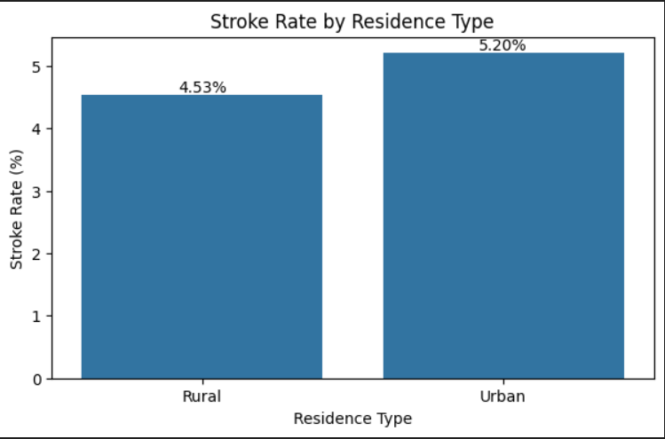

##### Question 2

Question: What percentage of smokers had a stroke vs. non-smokers?
Why: Smoking is a major risk factor for vascular disease.

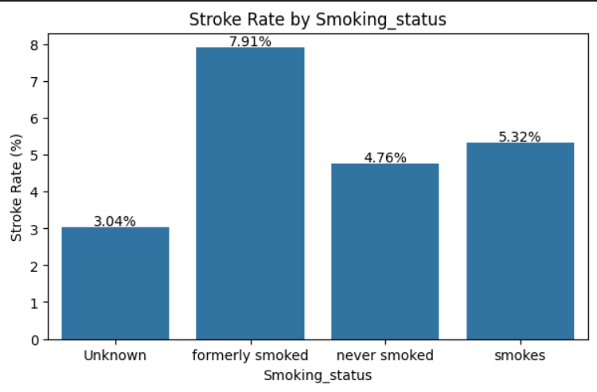

##### Question 3

Question: Which occupation type has the highest stroke percentage?
Why: Stress levels or physical activity could matter.

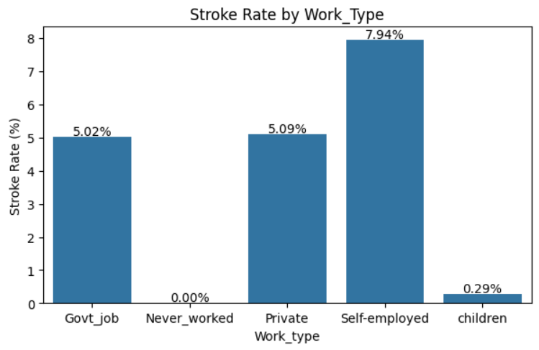

##### Question 4

Question: Which gender shows a higher stroke rate?
Why: Some studies suggest minor gender differences.

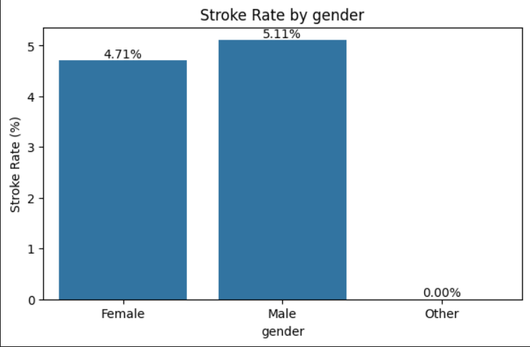

##### Question 5

Question: What percentage of people with hypertension had a stroke compared to those without?
Why: High blood pressure is a major stroke risk factor.

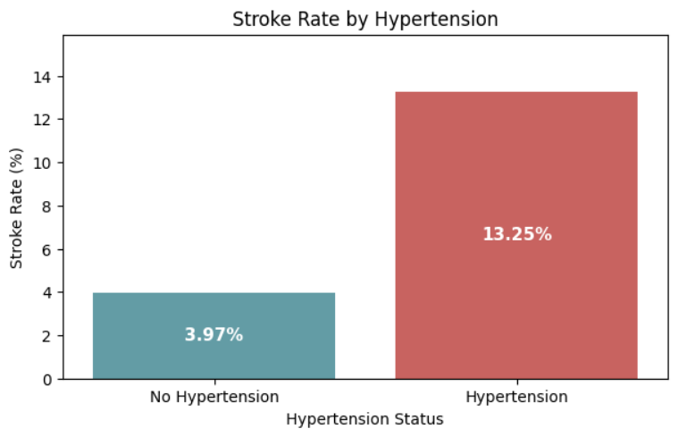

##### Question 6

This analysis explores how marital status (`ever_married`) relates to the likelihood of stroke.
We calculate the mean stroke rate for each marital group and visualize the comparison.

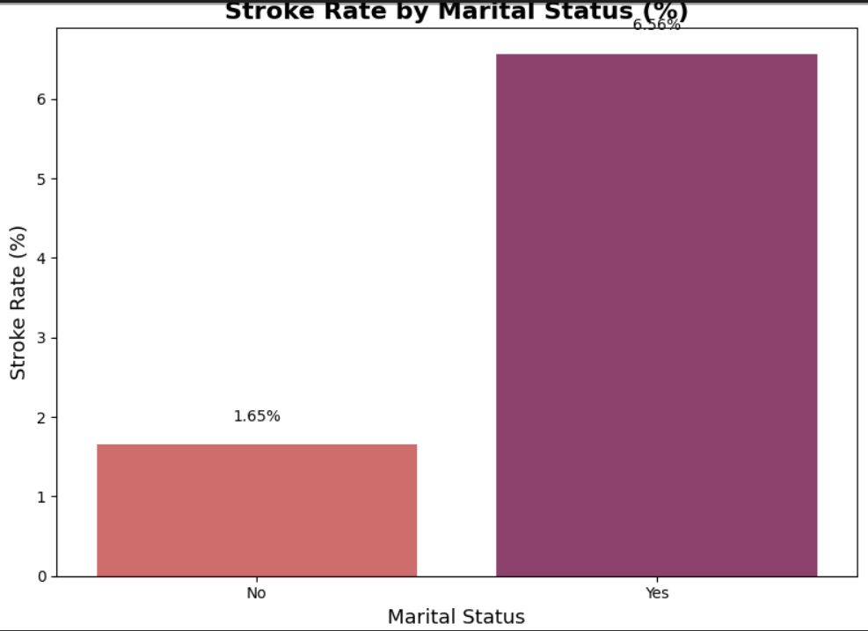

##### Question 7

This section analyzes the relationship between **Body Mass Index (BMI)** and the likelihood of stroke.
The BMI values are grouped into three categories — *Low*, *Normal*, and *High* — to observe differences in stroke occurrence.

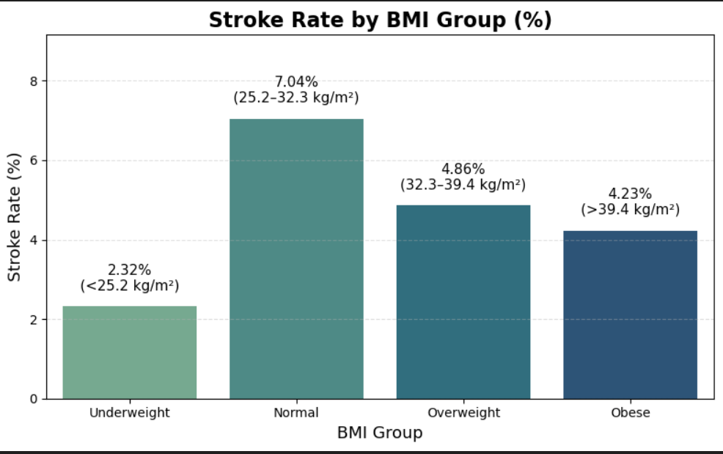

##### Question 8

This section explores how **heart disease** affects the likelihood of having a stroke.
By comparing individuals with and without heart disease, we can determine whether cardiovascular conditions increase stroke risk.

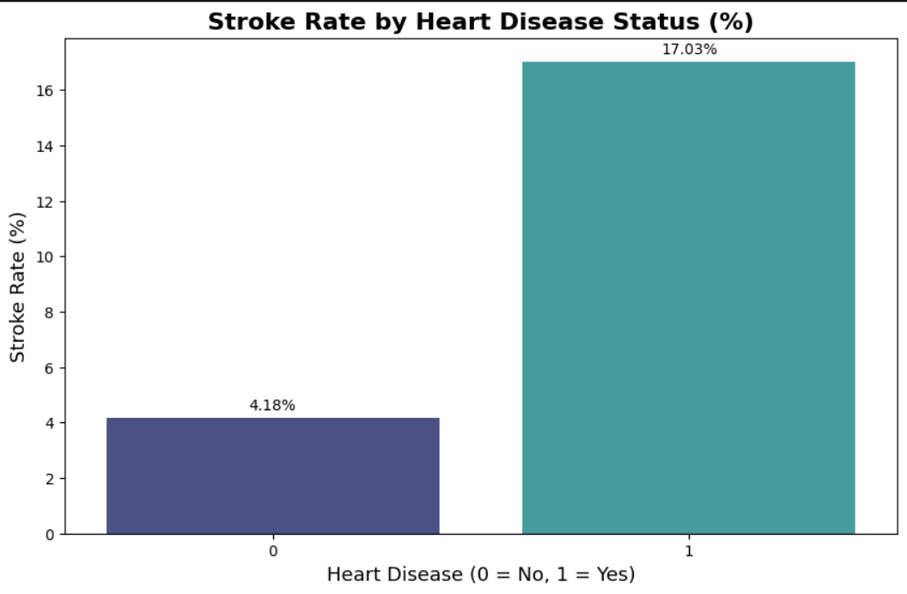

##### Question 9

This section analyzes how **average glucose levels** relate to the likelihood of a stroke.
Glucose levels are grouped into three categories — *Low*, *Normal*, and *High* — to identify whether higher glucose levels are linked to increased stroke risk.

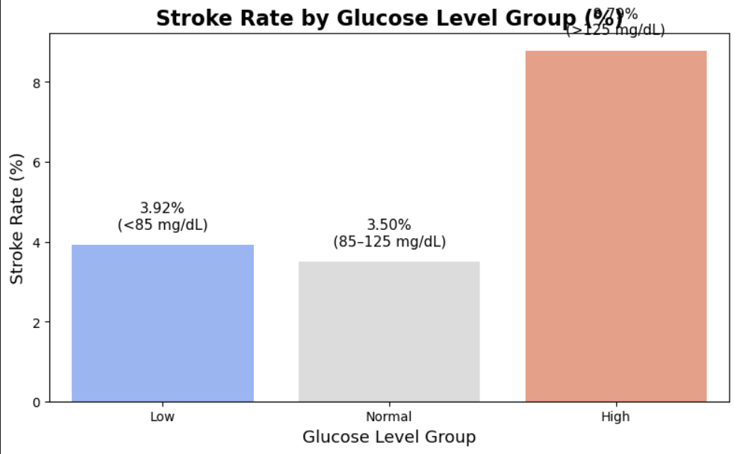

##### Question 10

This section examines how **age** affects the likelihood of having a stroke.
The data is divided into three age categories — *Younger*, *Middle-aged*, and *Older* — to explore whether stroke risk increases with age.
